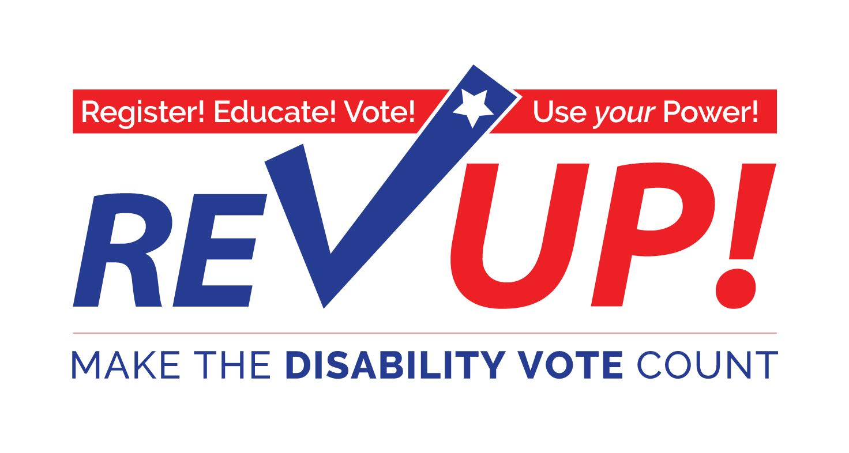

**Ways to Participate in**

**National Disability Voter Registration Week**

*July 11-15, 2016*

* Hold a press event or conference with local partners to announce national and local efforts to get new people with disabilities registered to vote, educated on disability issues, and committed to get out the DISABILITY VOTE. If possible, coordinate multiple sites around your state to host press events at the same time.
* Organize a rally of voters with disabilities and disability advocates to promote the REV UP message and the power of the DISABILITY VOTE.
* Write letters to the editor or Op-Eds and engage local radio or TV stations on the growing efforts by the disability community to become an influential voice in electoral politics this November and beyond.
* Utilize your mail, email, and social media networks to provide information on voter registration and relevant disability issues in your area while also getting encouraging people to commit to vote on Election Day.
* Host a workshop or training on state voter registration rules as well as your rights as a person with a disability.
* Collect Data on voters with disabilities in your area - this will help us build a broader movement to show the power of the disability voting bloc.
* Include REV UP and voter registration tables at upcoming events (especially any events around the 26th anniversary of the ADA).
* Connect with other disability rights and voting rights organizations in your area.
* Make your organization a polling place (Resources: How To Serve As A Polling Site and ADA Polling Place Checklist).
* Go to your City Council, County Commissioner, State Representative, etc. to get the week of 7/11 – 7/15 declared DISABILITY VOTER REGISTRATION WEEK (a draft Resolution is available here).